

**48V pack core module SW flashing procedures**

**SW flashing hardware needed: PEAK CAN USB dongle.**

**Setup (first time only)**

1. Safe the Flashing Environment:

Download and save the flashing environment on the desktop or location of your choice. This should have been provided from ABS via flash drive or drop box link

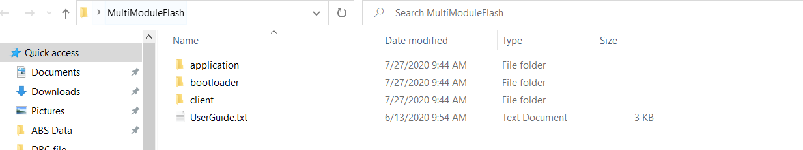

1. Install the Peak USB-CAN drivers:

<https://www.peak-system.com/quick/DrvSetup>

1. Install Bus Master:

(this is optional but allows you to see CAN traffic and read variables with the appropriate .dbf file)

<https://rbei-etas.github.io/busmaster/download.html>

1. Connect the Peak USB-CAN dongle

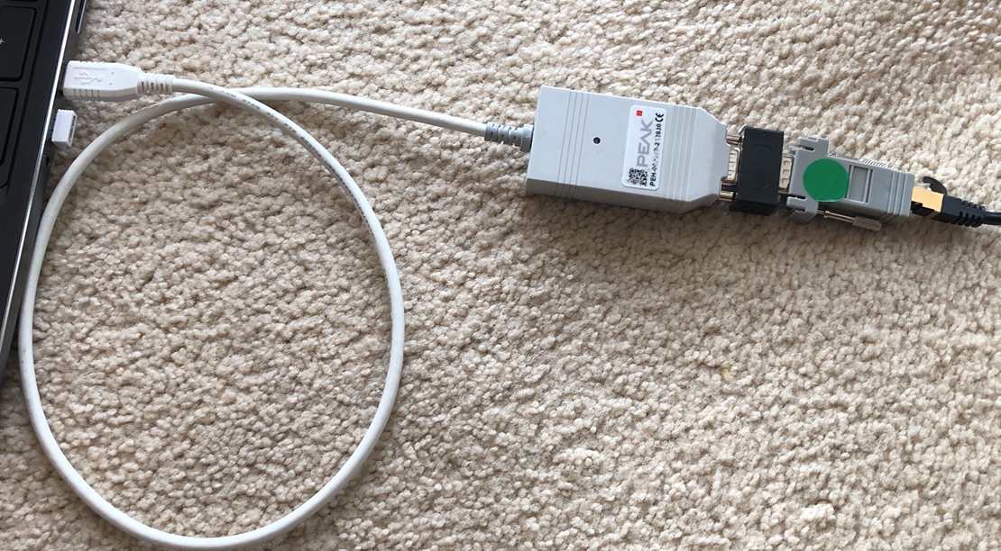

**Ethernet cable to battery**

**120 ohm Termination**

**RJ45 – DB9 adapter**

**Peak USB-CAN Dongle**

**Flashing steps:**

**Step 1: Make Connection**

Connect ONE Alliance Module external LV connector to the black or white ethernet splitter with an ethernet cable. Put the gold termination Ethernet connection into the empty space on splitter

**Step 2: Ensure correct Software is flashed**

In the flashing environment from the Setup section above, go to the folder Client\Hex and find the correct software to flash and copy it. The nomenclature for the software versions is the last digit indicated how many modules are configured. Below is an example of version 11 with 2 modules.

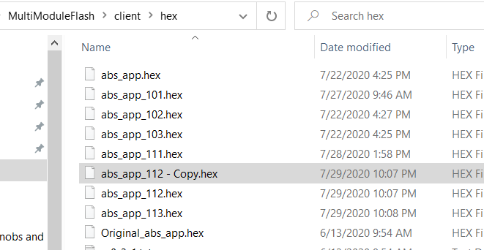

Delete the file abs_app.hex

Rename abs_app_112 – Copy.hex to abs_app.hex. The flashing tool will flash whatever software is called abs_app.hex

**Step 3: Ensure battery is NOT in Drive or Charge**

If using the ABS Development Display, Ensure battery is NOT in Drive or Charge. The Battery Status should indicate either Sleep, Standby, or Standby – Not Ready.

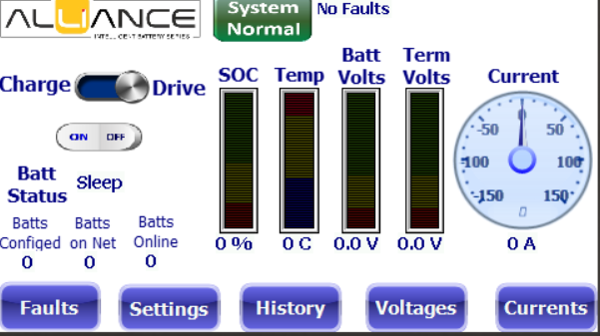

If NOT using the ABS Development Display, ensure the Ign- is OFF and the terminals do not have any voltage

**Step 4: Flash the battery**

Go to the folder: \client\windows_scripts and double click on the abs_program.app. There could be windows warning, just accept them and proceed

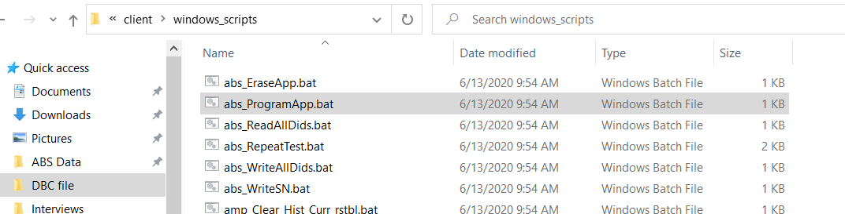

**Step 3: Flashing:**

Then the flashing script will run and automatically erase the old program and start flashing the new program to the BMS board. If it fails initially, go back to step 3 and ensure the battery is not in Drive or

**Step 4: Update Instance ID:**

If you are changing the number of modules in the pack, you will need to update the instance ID. This is the ID of the module in the pack, ie 0, 1, or 2 for a 3 module configuration. If the number of modules being configured is unchanged you may skip this step.

In the Windows_Script folder find the batch file for Update_Instance_IDx. All Instance ID’s must be unique. For the first module update with Instance0. You should get a “positive response” from the updater. If you don’t get the positive response, repeat until you do.

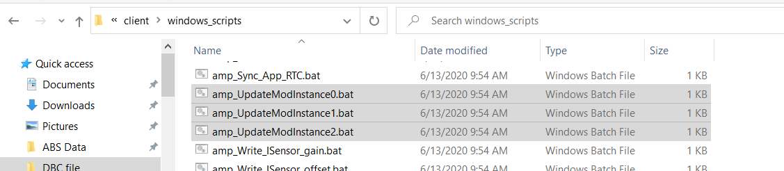

**Step 5: Update additional modules:**

Move the Alliance LV connector to the next module that you want to update and repeat steps 3 and 4 as appropriate until all modules have been updated.